# Notice of rent increase to tenant/s of rented premises

***Residential Tenancies Act 1997* (the Act) Section 44**

**Residential Tenancies Regulations 2019, Regulation 11**

**Note:** Enter text in spaces provided only. This form will be invalid if you remove or change any questions or other text.

**Use this form to give notice to tenant/s of a rent increase if you are a**:

* landlord of rented premises, or
* specialist disability accommodation (SDA) provider who has an SDA resident living in an SDA enrolled dwelling under either:
* a residential tenancy agreement, or
* an SDA residency agreement.

This form refers to you as the ‘landlord’ and the SDA resident as the ‘tenant’.

Please note:

* You can only use this form to notify of one rent increase at a time.
* Landlords cannot increase rent more often than once every:
* six months, under an SDA residency agreement
* six months, under a tenancy agreement entered into before 19 June 2019, or
* 12 months, under a tenancy agreement entered into   
  on or after 19 June 2019.

## How to use this form

### 1. Complete parts 1 to 7

You must complete all boxes.

### 2. Complete part 8

Write in the new rent amount and the date on which the rent increase will start (date must be at least 60 days from the date of this notice).

### 3. Sign part 9 and write your name at part 10

### 4. When the form is complete

Tear out the top two forms (Tenant’s copies) and send both to the tenant.

Keep the last copy of the form for your records.

## How to serve this notice

**You can serve this notice by hand, by post or by email (with consent).**

If you send a notice by post, you must take into account the extra days it takes for the notice to be delivered. Australia Post has three different speeds for ordinary mail delivery – express, priority and regular mail, which may take up to six days. Priority and regular delivery speeds also apply for registered post. You may wish to keep evidence of the mail delivery method you relied on to send this notice.

For more information about Australia Post’s mail delivery options and times, visit the [Australia Post website](http://www.auspost.com.au/) (auspost.com.au).You can only send this notice by email if you already have the tenant/s’ written consent to receive notices and other documents this way. The tenant/s may have given consent in the tenancy agreement or separately in writing. A consent form is available from the [Forms and publications section – Consumer Affairs Victoria website](https://www.consumer.vic.gov.au/forms) (consumer.vic.gov.au/forms).

If you send this notice by email, the provisions of the *Electronic Transactions (Victoria) Act 2000* apply. For legal purposes, the time when a notice is received is when it can be retrieved from the email address the recipient nominated.

To help calculate the total minimum days to allow, depending on the notice period required and the method of delivery, visit the [Giving notices – Residential Tenancies List page – Victorian Civil and Administrative Tribunal (VCAT) website](https://www.vcat.vic.gov.au/resources/giving-notices-residential-tenancies-list) (vcat.vic.gov.au/resources/giving-notices-residential-  
tenancies-list).

If you need help with this notice, visit the [Renting   
section – Consumer Affairs Victoria website](file:///C:\Users\amacglas\AppData\Roaming\Hewlett-Packard\HP%20TRIM\Offline%20Records%20(P1)\Form%20~%20increase%20to%20tenant%20s%20of%20rented%20premises\consumer.vic.gov.au\renting) (consumer.vic.gov.au/renting) or call the Consumer Affairs Victoria Helpline on 1300 55 81 81.

## Telephone Interpreter Service

If you have difficulty understanding English, contact the Translating and Interpreting Service (TIS) on 131 450 (for the cost of a local call) and ask to be put through to an Information Officer at Consumer Affairs Victoria on 1300 55 81 81.

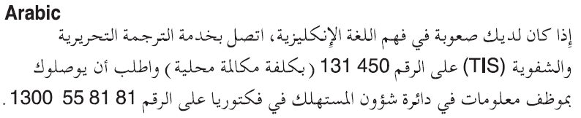

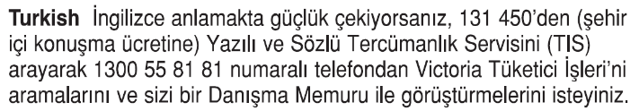

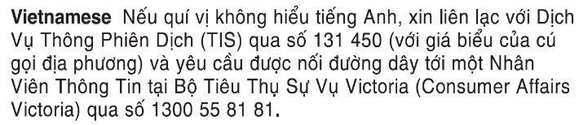



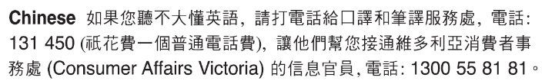

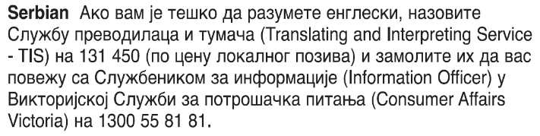



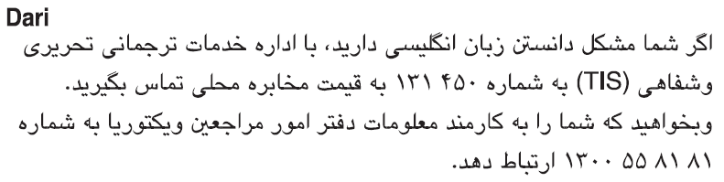



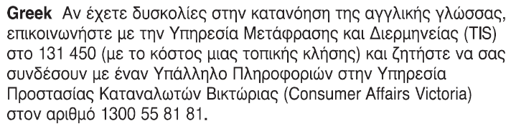

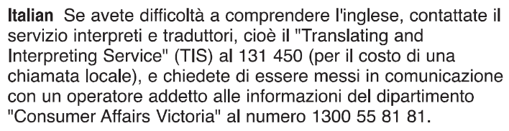

Information about renting is available in other languages at [consumer.vic.gov.au/languages](https://www.consumer.vic.gov.au/languages).

# Notice of rent increase to tenant/s of rented premises From the landlord

***Residential Tenancies Act 1997* (the Act) Section 44 Tenant’s copy**

**Residential Tenancies Regulations 2019, Regulation 11**

## Tenant details

1. This notice is given to: *(tenant/s names)*

|  |
| --- |
|  |

1. Regarding the rented premises at: *(write address)*

|  |
| --- |
|  |

1. Tenant/s address: *(if same address as 2, write ‘as above’)*

|  |
| --- |
|  |

## Landlord details

1. Name of landlord (of the rented premises):   
   *(insert name of landlord, cannot be an agent’s name)*

|  |
| --- |
|  |

1. Address of landlord (of the rented premises) for the purpose of serving documents: (*can be an agent’s address)*

|  |
| --- |
|  |

1. Contact telephone numbers (of landlord or agent):

|  |  |
| --- | --- |
| Business hours: |  |
| After hours: |  |

## Service details

1. This notice is given to the tenant: *(mark one method only and if posted, note the delivery speed)*

|  |  |
| --- | --- |
| by hand: |  |
| by registered post: |  |
| by ordinary post: |  |
| by email: |  |
| Insert email address: (if applicable) |  |
| on this date:  *(dd/mm/yyyy)* | / / |

## Rent increase amount and start date

1. I am giving you at least 60 days notice that I propose to increase the rent.

|  |  |
| --- | --- |
| The current rent is: *($)* |  |
| Per: *(week/fortnight/month)* |  |
| The new rent is: *($)* |  |
| Per: *(week/fortnight/month)* |  |
| and will commence on: *(start date)* | / / |

1. Signature of landlord or agent:

|  |
| --- |
|  |

1. Name of landlord or agent signing this notice:   
   *(include name of estate agency where applicable)*

|  |
| --- |
|  |

1. If you consider this proposed rent increase is excessive, you can apply to the Director of Consumer Affairs Victoria within 30 days after this notice is given to investigate and report on the proposed rent, under section 45 of the *Residential Tenancies Act 1997.*

**Tenants note:** Excessive rent is determined according to the accepted market rental value of the premises.

1. Under a tenancy agreement entered into before   
   19 June 2019, the landlord cannot increase your rent more than once every 6 months.   
   Under a tenancy agreement entered into on or after 19 June 2019, the landlord cannot increase your rent more than once every 12 months.
2. Under a fixed term tenancy agreement, a landlord must not increase the rent before the fixed term ends unless the agreement specifically provides for an increase.
3. If you need help with this notice, you can call the Consumer Affairs Victoria Helpline on 1300 55 81 81 or visit [consumer.vic.gov.au/renting](http://www.consumer.vic.gov.au/renting)

## Rent increase investigation (no cost)

*(note: this section is not part of the notice)*

If you want to request an investigation, it must be in writing.

You can apply for an investigation, by ticking the box below, writing your daytime telephone number, and posting a copy of this form to Director of Consumer Affairs Victoria, GPO Box 123 Melbourne 3001, or email to [renting@justice.vic.gov.au](mailto:renting@justice.vic.gov.au)

After your request has been received, a Residential Tenancies Inspector will contact you.

(Continued on next page)

|  |  |  |
| --- | --- | --- |
| Yes, I/we the tenant/s wish to apply for a rent increase investigation: | |  |
| Tenant/s daytime telephone number: |  | |

**Privacy notification** – Consumer Affairs Victoria collects and handles your personal information consistent with the requirements of the *Privacy and Data Protection Act 2014*. Without this information we may be unable to process this transaction.

You are able to request access to the personal information that we hold about you, and to request that it be corrected by contacting Consumer Affairs on 1300 55 81 81, the Information and Privacy Unit on 8684 0178 or the Freedom of Information Unit on 8684 0063.

# Notice of rent increase to tenant/s of rented premises From the landlord

***Residential Tenancies Act 1997* (the Act) Section 44 Tenant’s copy**

**Residential Tenancies Regulations 2019, Regulation 11**

## Tenant details

1. This notice is given to: *(tenant/s names)*

|  |
| --- |
|  |

1. Regarding the rented premises at: *(write address)*

|  |
| --- |
|  |

1. Tenant/s address: *(if same address as 2, write ‘as above’)*

|  |
| --- |
|  |

## Landlord details

1. Name of landlord (of the rented premises):   
   *(insert name of landlord, cannot be an agent’s name)*

|  |
| --- |
|  |

1. Address of landlord (of the rented premises) for the purpose of serving documents: (*can be an agent’s address)*

|  |
| --- |
|  |

1. Contact telephone numbers (of landlord or agent):

|  |  |
| --- | --- |
| Business hours: |  |
| After hours: |  |

## Service details

1. This notice is given to the tenant: *(mark one method only and if posted, note the delivery speed)*

|  |  |
| --- | --- |
| by hand: |  |
| by registered post: |  |
| by ordinary post: |  |
| by email: |  |
| Insert email address: (if applicable) |  |
| on this date:  *(dd/mm/yyyy)* | / / |

## Rent increase amount and start date

1. I am giving you at least 60 days notice that I propose to increase the rent.

|  |  |
| --- | --- |
| The current rent is: *($)* |  |
| Per: *(week/fortnight/month)* |  |
| The new rent is: *($)* |  |
| Per: *(week/fortnight/month)* |  |
| and will commence on: *(start date)* | / / |

1. Signature of landlord or agent:

|  |
| --- |
|  |

1. Name of landlord or agent signing this notice:   
   *(include name of estate agency where applicable)*

|  |
| --- |
|  |

1. If you consider this proposed rent increase is excessive, you can apply to the Director of Consumer Affairs Victoria within 30 days after this notice is given to investigate and report on the proposed rent, under section 45 of the *Residential Tenancies Act 1997.*

**Tenants note:** Excessive rent is determined according to the accepted market rental value of the premises.

1. Under a tenancy agreement entered into before   
   19 June 2019, the landlord cannot increase your rent more than once every 6 months.   
   Under a tenancy agreement entered into on or after 19 June 2019, the landlord cannot increase your rent more than once every 12 months.
2. Under a fixed term tenancy agreement, a landlord must not increase the rent before the fixed term ends unless the agreement specifically provides for an increase.
3. If you need help with this notice, you can call the Consumer Affairs Victoria Helpline on 1300 55 81 81 or visit [consumer.vic.gov.au/renting](http://www.consumer.vic.gov.au/renting)

## Rent increase investigation (no cost)

*(note: this section is not part of the notice)*

If you want to request an investigation, it must be in writing.

You can apply for an investigation, by ticking the box below, writing your daytime telephone number, and posting a copy of this form to Director of Consumer Affairs Victoria, GPO Box 123 Melbourne 3001, or email to [renting@justice.vic.gov.au](mailto:renting@justice.vic.gov.au)

After your request has been received, a Residential Tenancies Inspector will contact you.

(*Continued on next page*)

|  |  |  |
| --- | --- | --- |
| Yes, I/we the tenant/s wish to apply for a rent increase investigation: | |  |
| Tenant/s daytime telephone number: |  | |

**Privacy notification** – Consumer Affairs Victoria collects and handles your personal information consistent with the requirements of the *Privacy and Data Protection Act 2014*. Without this information we may be unable to process this transaction.

You are able to request access to the personal information that we hold about you, and to request that it be corrected by contacting Consumer Affairs on 1300 55 81 81, the Information and Privacy Unit on 8684 0178 or the Freedom of Information Unit on 8684 0063.

# Notice of rent increase to tenant/s of rented premises From the landlord

***Residential Tenancies Act 1997* (the Act) Section 44 Landlord’s copy**

**Residential Tenancies Regulations 2019, Regulation 11**

## Tenant details

1. This notice is given to: *(tenant/s names)*

|  |
| --- |
|  |

1. Regarding the rented premises at: *(write address)*

|  |
| --- |
|  |

1. Tenant/s address: *(if same address as 2, write ‘as above’)*

|  |
| --- |
|  |

## Landlord details

1. Name of landlord (of the rented premises):   
   *(insert name of landlord, cannot be an agent’s name)*

|  |
| --- |
|  |

1. Address of landlord (of the rented premises) for the purpose of serving documents: (*can be an agent’s address)*

|  |
| --- |
|  |

1. Contact telephone numbers (of landlord or agent):

|  |  |
| --- | --- |
| Business hours: |  |
| After hours: |  |

## Service details

1. This notice is given to the tenant: *(mark one method only and if posted, note the delivery speed)*

|  |  |
| --- | --- |
| by hand: |  |
| by registered post: |  |
| by ordinary post: |  |
| by email: |  |
| Insert email address: (if applicable) |  |
| on this date:  *(dd/mm/yyyy)* | / / |

## Rent increase amount and start date

1. I am giving you at least 60 days notice that I propose to increase the rent.

|  |  |
| --- | --- |
| The current rent is: *($)* |  |
| Per: *(week/fortnight/month)* |  |
| The new rent is: *($)* |  |
| Per: *(week/fortnight/month)* |  |
| and will commence on: *(start date)* | / / |

1. Signature of landlord or agent:

|  |
| --- |
|  |

1. Name of landlord or agent signing this notice:   
   *(include name of estate agency where applicable)*

|  |
| --- |
|  |

1. If you consider this proposed rent increase is excessive, you can apply to the Director of Consumer Affairs Victoria within 30 days after this notice is given to investigate and report on the proposed rent, under section 45 of the *Residential Tenancies Act 1997.*

**Tenants note:** Excessive rent is determined according to the accepted market rental value of the premises.

1. Under a tenancy agreement entered into before   
   19 June 2019, the landlord cannot increase your rent more than once every 6 months.   
   Under a tenancy agreement entered into on or after 19 June 2019, the landlord cannot increase your rent more than once every 12 months.
2. Under a fixed term tenancy agreement, a landlord must not increase the rent before the fixed term ends unless the agreement specifically provides for an increase.
3. If you need help with this notice, you can call the Consumer Affairs Victoria Helpline on 1300 55 81 81 or visit [consumer.vic.gov.au/renting](http://www.consumer.vic.gov.au/renting)

## Rent increase investigation (no cost)

*(note: this section is not part of the notice)*

If you want to request an investigation, it must be in writing.

You can apply for an investigation, by ticking the box below, writing your daytime telephone number, and posting a copy of this form to Director of Consumer Affairs Victoria, GPO Box 123 Melbourne 3001, or email to [renting@justice.vic.gov.au](mailto:renting@justice.vic.gov.au)

After your request has been received, a Residential Tenancies Inspector will contact you.

(*Continued on next page*)

|  |  |  |
| --- | --- | --- |
| Yes, I/we the tenant/s wish to apply for a rent increase investigation: | |  |
| Tenant/s daytime telephone number: |  | |

**Privacy notification** – Consumer Affairs Victoria collects and handles your personal information consistent with the requirements of the *Privacy and Data Protection Act 2014*. Without this information we may be unable to process this transaction.

You are able to request access to the personal information that we hold about you, and to request that it be corrected by contacting Consumer Affairs on 1300 55 81 81, the Information and Privacy Unit on 8684 0178 or the Freedom of Information Unit on 8684 0063.